Open Selection Trials – 2025-26 ( Cadet )
7 ~ 10 August 2025 at SAI Bhopal, M.P.
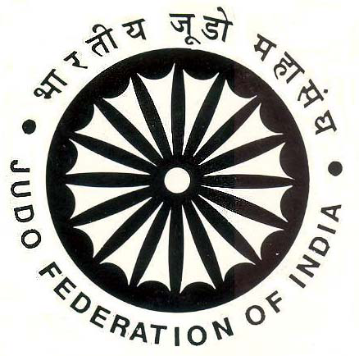 Entry Form – BOYS
Please send this Entry on or before 31st July 2025, to Email : jfiindia@gmail.com & regnjfi@gmail.com
Name of State/ UT :
S. No. | Wt. Category |  | Name | Date of Birth | Father’s name | JFI Regn. ID | Mobile Number | Email ID
 |  | I have verified the birth certificates/documents of the above examinee and found correct. Certified that none of the above athletes are not facing any violation of Anti-Doping Rules, Age Fraud, Sexual and Metal harassment cases, or any enquiry is pending. The undersigned / association is responsible for any misconduct on the same as well as during the event.
President/Secretary
Signature & Stamp

Open Selection Trials – 2025-26 ( Cadet )
7 ~ 10 August 2025 at SAI Bhopal, M.P.

Entry Form – GIRLS
Please send this Entry on or before 31st July 2025, to Email : jfiindia@gmail.com & regnjfi@gmail.com
Name of State/ UT. :
S. No. | Wt. Category |  | Name | Date of Birth | Father’s Name | JFI Regn. ID | Mobile Number | Email ID
 |  | I have verified the birth certificates/documents of the above examinee and found correct. Certified that none of the above athletes are not facing any violation of Anti-Doping Rules, Age Fraud, Sexual and Metal harassment cases, or any enquiry is pending. The undersigned / association is responsible for any misconduct on the same as well as during the event.
President/Secretary.
Signature & Stamp

